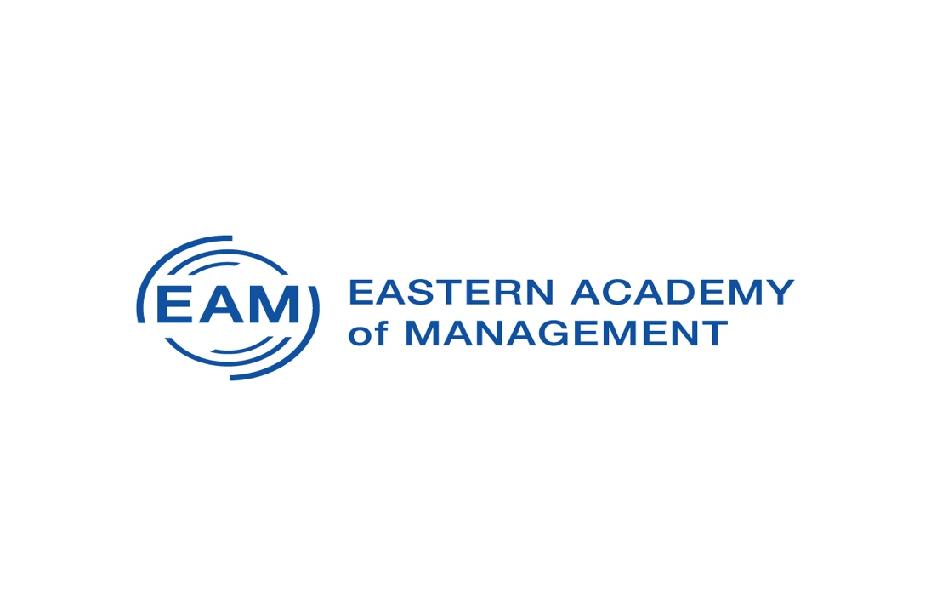
58th Annual Meeting of The Eastern Academy of Management
May 19-22, 2021(Virtual)
www.eaom.org

From a global health pandemic to racial injustice, the year 2020 has brought forward unprecedented challenges for both organizations and management education. These evolving public health and societal events highlight the importance of responsible leadership more than ever before. While responsible management/leadership and Principles of Responsible Management Education (PRME) have been increasingly incorporated into management education, the rapidly changing world in which we live presents the need to continuously frame and reframe responsible management/leadership, responsible management education, and research into organizational social responsibility. Among the questions we need to address are; What are the skills/abilities required for engaging in responsible leadership? Why are some companies more responsive to global problems than others? How should we teach our students to be sensitive to global issues that they do not experience first-hand? What can business schools do to develop socially relevant and responsive mindsets? What is the role of entrepreneurship in responsible leadership? How do organizational structures, cultures, and identities help or hinder responsible management? The EAM community will explore these and other management issues in research, teaching, and learning.

Submission Deadline Extended to January 31st, 2021
Click here to submit your work
Program Chair: Tejinder K. Billing, William G. Rohrer College of Business,
Rowan University

Conference Theme: Responsible Management: Challenges & Opportunities

TRADITIONAL PAPER SUBMISSIONS TRACKS

Strategy, International Management  Track Chairs: Vishal Gupta, University of Alabama,  Shanti Gopalakrishnan, New Jersey Institute of Technology, | Entrepreneurship & Innovation  Track Chairs: Huy (David) Tran, Albright College,  Heidi Bertels, College of Staten Island, CUNY,
Organizational Behavior  Track Chairs: Antigoni Papadimitriou,  Western Kentucky University,  Robin Frakal, Nichols College | Human Resource Management  Track Chairs: Alison Wall, Southern Connecticut State University
Ethics, CSR, & Sustainability  Track Chair: Gail Latta, Xavier University. | Crisis Management/ Hospitality Track  Track Chair: Noel Criscione-Naylor  Stockton University

Management Education & Development
Track Chair: Ted Peters, University of Baltimore;
Joy Jones, Stockton University

ALTERNATIVE FORM TRACKS
Experiential Learning Activities (ELA)  Track Chair: Noel Criscione-Naylor  Stockton University | Poster Sessions  Track chair: Jestine Philips  University of New Haven
Idea Incubator  Track Chairs: Pamela Derfus, St. Thomas Aquinas College; Julaine Rigg, Morgan State University | Professional Development Workshops (PDW)  Track Chair: Julie Stanton, Penn State Brandywine
Teaching Cases and case-related work (CASE)
Track Chairs: Miriam Weismann, Chris Ellis, Florida International University

More information about the tracks can be found at www.eaom.org/2021/tracks
GUIDELINES FOR SUBMISSON
- Submissions may take the form of conceptual or empirical paper, panel discussions, symposium, poster, case, or experiential learning session. All submissions are to be written in English, follow Eastern Academy of Management guidelines available at https://www.eaom.org/Guidelines-for-submission and be made via the conference website at https://www.eaom.org/EAM2021 before the submission deadline, January 31st, 2021. The submission portal will open October 15, 2020.
- Refereed Scholarly Submissions
To help protect the integrity of the submission and review process, papers and symposia are blind reviewed.
Papers are double-blind reviewed, and are evaluated on clarity, analysis, methodological rigor and overall quality. Double-blind review means that author and submitter information is NOT known to the reviewers, and reviewer information is NOT known to the authors or submitter.
Symposia are single-blind reviewed, and are judged on overall quality, interest to EAM members, relevance to the division or interest group to which they are submitted, and innovation and contribution. Single-blind review means that author and submitter information IS known to the reviewers, but reviewer information is NOT known to the authors or submitter.
- Your paper must not have been previously presented or scheduled for presentation anywhere. Submitted papers must not have been published or accepted for publication. If a paper is under review, it must NOT appear in print before the EAM meeting. Subsequent publication elsewhere, with proper acknowledgement, is encouraged.
- During submission you must indicate
  - − one suitable track for the submission, See track descriptions at
http://eaom.org/2021/tracks
  - − whether it relates to the conference theme
  - − the submission type - paper, panel discussion, symposium, poster, case, or experiential learning activity.
  - − Whether the submission is by a student
- If a proposed idea does not seem to fit any of the track descriptions, authors should contact Program Chair. Your submissions will be directed to the most appropriate track.
- The entire paper submission (abstract, main text, figures, graphs, tables, references, etc.) must be in ONE document submitted in Microsoft Word (.doc, .docx) or .pdf file format. DO NOT INCLUDE AUTHORNAME(S) ON THE TITLE PAGE. Supplementary file(s) may be uploaded to support the main submission.
- If your submission is accepted, at least one author (for symposium/panels and workshops, every author) must register and present their work at the conference. No participant is allowed to be included as an author/presenter in more than three program sessions. All authors are expected to serve as conference reviewers.
For Submission Guidelines and manuscript formatting for submission to the CASE Association, please visit: https://www.caseweb.org/resources/
MANUSCRIPT FORMATTING FOR SCHOLARLY PAPER
- A paper refers to a fully developed manuscript on a scholarly topic.
- It should be written as:
− title on each page (no author information);
− abstract, keywords;
− introduction, theoretical background, data and methods, results, discussion;
− references (in APA style); appendices (as appropriate); table(s) with caption(s) (on individual pages); figures; figure captions.
- Each paper can be submitted to only ONE track.
- Submission should be a maximum of 20 double-spaced pages of text, with no more than
10 additional pages of tables, figures, references and appendices. References may be
single-spaced.
- Your manuscript should be submitted as ONED file in Microsoft Word (.doc, .docx) or
.pdf file format. All text in the manuscript should be double spaced, with a 1-inch margin on all four sides. The paper size should be set to ‘Letter’ (8.5 inches X 11 inches). Manuscripts should be prepared in Times New Roman Font, Font size 12.
- Your submission will be blind peer reviewed, so it is very important that you ensure that author names and identifying information does not appear anywhere in your manuscript, not even on the title page (this does not apply to symposia/panels and workshops as they are not blind reviewed).

MANUSCRIPT FORMATTING FOR PANEL AND SYMPOSIUM
Proposal for a panel or a symposium are not double blind reviewed. A symposium can be in either a panel format or a presenter format. A panel symposium engages a group of panelists in a formal, interactive discussion around a topic. A presenter symposium involves a collection of authored papers revolving around a common theme. We are especially interested in symposium related to the Conference Theme: Being Human in the Digital World. Panel/Symposium may run for 30, 45, or 60-minute sessions, depending on space available. A panel or symposium can be submitted to only one track.
Your manuscript should be submitted as ONE file in Microsoft Word (.doc, .docx) or .pdf file format. All text in the manuscript should be double spaced, with a 1-inch margin on all four sides. The paper size should be set to ‘Letter’ (8.5 inches X 11 inches). Manuscripts should be prepared in Times New Roman Font, Font size 12.
In your proposal, please include:
- Proposal title, names and contact information for all participants
- An overview of the panel/symposium, with references (in APA style). References may be single-spaced.
- A synopsis of each participant’s contribution
- A ranking of preferred time options (30, 45 or 60 minutes)
MANUSCRIPT FORMATTING FOR POSTER
Research posters summarize information or research concisely and attractively to help publicize it and generate discussion. The poster is usually a mixture of a brief text mixed with tables, graphs, pictures, and other presentation formats. At a conference, the researcher stands by the poster display while other participants can come and view the presentation and interact with the author. GRADUATE STUDENTS ARE ESPECIALLY ENCOURAGED TO SUBMIT.
To submit a poster, you’ll need to submit ONE file in Microsoft Word (.doc, .docx) or .pdf format with the following information:
- Poster title - Posters should have a succinct title that describes the main finding of your research. Keep in mind that the poster title will be listed in conference program without the abstract and meeting attendees often use the titles to decide which posters to visit. When possible, the title should indicate the important result, rather than the experimental question.
- Poster abstract - The abstract should briefly describe your research findings (up to 250 words).
- Track - Choose the track to which your research belongs.
- Keyword - Select three keywords that best represents your poster. Keywords are used to organize presentations by topic in poster sessions.
- Summary - The summary describes the study in detail, including methods and results (up to 1000 words). The references do not count toward the word limit. Use APA citation style for references.
MANUSCRIPT FORMATTING FOR EXPERIENTIAL LEARNING ACTIVITIES
- Experiential exercises include structured activities, role plays, simulations and other forms that create active student involvement. Exercises should be original or represent substantial modifications of existing exercises (if a modification, also include the original exercise as an appendix)
- Your manuscript should be submitted as ONE file in Microsoft Word (.doc, .docx) or .pdf format. Supplementary files may be uploaded. All text in the manuscript should be double spaced, with a 1-inch margin on all four sides. The paper size should be set to ‘Letter’ (8.5 inches X 11 inches). Manuscripts should be prepared in Times New Roman Font, Font size 12.
- Your submission will be blind peer reviewed, so it is very important that you ensure that author names and identifying information does not appear anywhere in your manuscript, not even on the title page
- Papers for experiential exercises should include 8 parts
  - Introduction to the exercise –write a short rationale for why the topic is important/relevant to the study of management, concepts or theories typically taught, and how the exercise will facilitate student learning. You need not review why experiential learning is needed.
  - Instructions for presenting the exercise including the following: a) learning goals, b) approximate timing for whole exercise and individual parts, c)number of participants or group size, d) materials and technology needed, e)appropriate level (undergrad, grad, executive), and f) preparation needed for students and for the instructor.
  - Teaching notes –describe in detail the steps and timing involved in doing the exercise. Try to write instructions that assume the instructor has never seen the exercise before and wants to use it the following day in class.
  - Debriefing –discuss in detail how you debrief the exercise. Include specific questions for the instructor to ask to process the exercise, hints on ways to make the exercise work effectively, what could be expected when running the exercise, and possible variations in the use of the exercise.
  - A summary of students’ reaction to the exercise.
- Presentation at ELA –explain how the exercise will be demonstrated during a 30- minute session at the ELA Conference. Discuss the extent to which session attendees will be able to participate in the exercise.
- References (in APA style). References may be single-spaced.
- Appendices –a copy of the complete exercise and any handouts, materials or resources used in the exercise.
• Submissions generally should be no longer than 30 pages including appendices but may be shorter if the above parts are all included.
PROFESSIONAL DEVELOPMENT WORKSHOP (PDW) SUBMISSION GUIDELINES
The Professional Development Workshops (PDWs) are a platform for colleagues to share knowledge and expertise and foster the professional development of workshop participants. It is an opportunity to develop innovative and creative workshops that will benefit EAM members. PDW proposals can be submitted only to the PDW track.
Proposals must be a minimum of 4 pages and must include and be organized in the following order:
- Page 1: Title page which contains up to 250-word abstract of the workshop
- Page 2: One page explanation as to why the workshop should be of interest
- Page 3: One page description of the workshops' format
- Page(s) 4-6: One to three pages overview of the workshop
PDW Proposals should use the following page format: Times New Roman 12-point font, double-spaced, 1-inch (2.5cm) margin all around, 8.5" x 11" page setting. Your proposal should be submitted as ONE file in Microsoft Word (.doc, .docx) or .pdf format.

