Spatial Chat Instructions
Spatial Chat is an online platform that allows users to interact with each other through different “hangout” areas, as well as provides the user with the ability to select different spaces in a room. You will have a bubble that shows your picture or video and shows your location in the room. As you approach other users (i.e., session attendees or speakers) you will notice their “bubble” get larger as you draw closer to them. You will be able to hear and speak with other users when are you in close proximity to them (just like in a physical space). Also, a microphone icon in the bottom righthand corner of their video/picture bubble will indicate whether their audio is enabled or disabled.
If there is a group conversation going on, you will be able to hear and see all people who are conversing when you move your bubble closer to theirs. Once you are next to others involved in a group conversation, you can then speak with them, and move your bubble away to leave.
When you choose to leave or join a different session or room, you will no longer be able to hear others and others will no longer be able to hear you within that current space. Once you join a new session, others will immediately be able to hear and see you in that room unless you disable your microphone/camera.
We think using this tool will provide poster session attendees as close to a face-to-face experience. We hope you will run into your friends, people during the events that you have not seen in years and make some new connections during these events.
You can join the EAM Conference HERE
You can see Spatial Chat help HERE

Setting Up
On the homepage of EAM’s spatial chat webpage,
- you will be asked to provide your name and a brief description.
- Click Continue.
- Next, it will ask you if you want your camera on (please turn it on) and click on join space. Be sure Zoom is closed and no other programs are using your camera and microphone before you accept. It is recommended to use Chrome or Firefox for SpatialChat. ***If you are attending a Poster session on Spatial Chat, you will NOT be able to attend other paper sessions that are occurring on Zoom during that time. This is because your video and audio can only be utilized either for Zoom or for Spatial Chat. So, please plan accordingly to attend sessions of your choosing.***
- You will then enter the Spatial Chat meeting space with your bubble and be provided with a quick tutorial on how to navigate the space and the features you can access.
There are customization options at the bottom of the screen. You can share content, share your screen, turn your camera/microphone on and off, and chat with other users. In the bottom righthand side of the screen, you will see an icon indicating zoom in/out feature on your screen. Use this feature to zoom out and see everyone in the meeting space, or zoom in to see who is in the specific area you are in (see picture below showing lounge areas).
On the right, you will also see the different rooms available and how many individuals are in each room. We will have 2-3 rooms during EAM’s social hour depending on attendance as each rooms only allows 50 people. When you click on a different room you will automatically be brought to that room.
Socializing
As you move your bubble through the space, you can talk to people if you get close to them. As you get closer to someone, you will be able to hear them louder and louder moving closer and closer. You are also able to see that someone is talking as their bubble will light up and get larger.
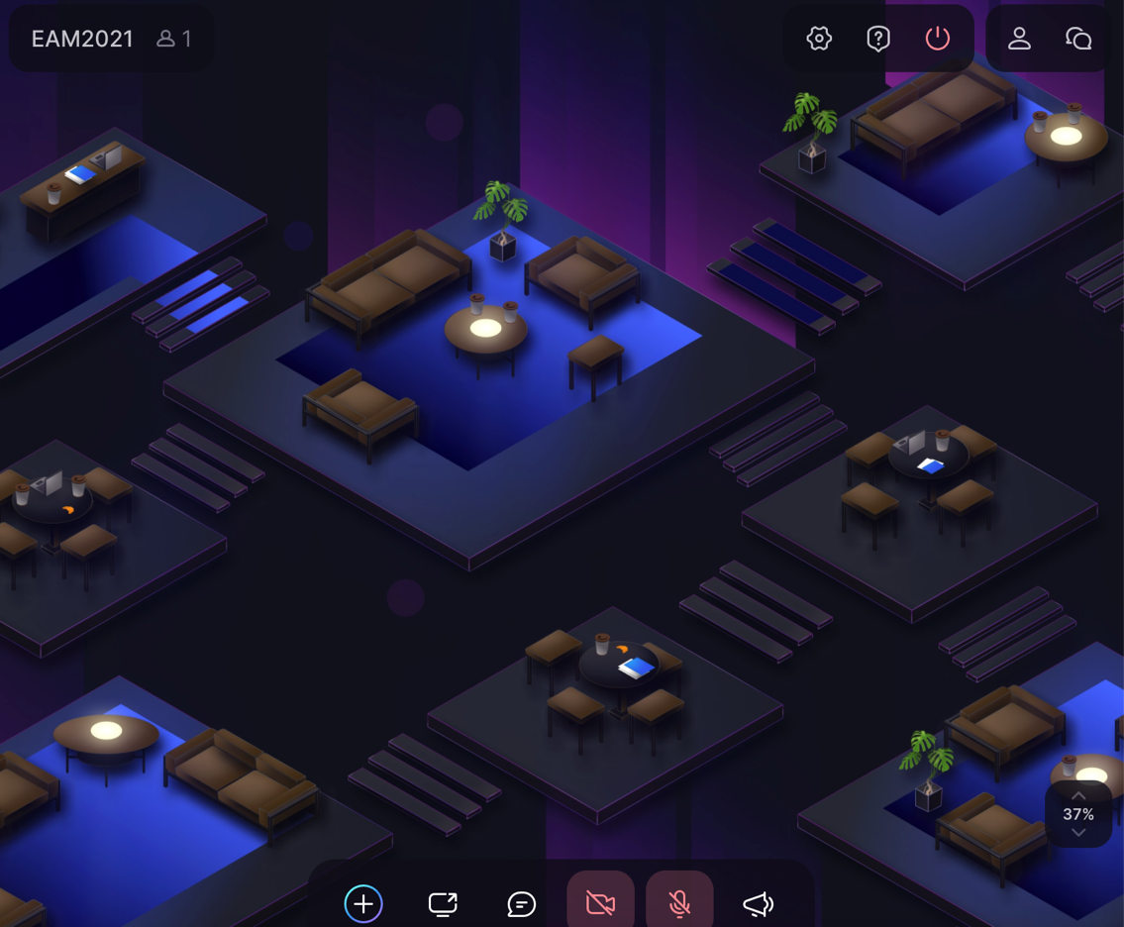
Zoom in/out % will be displayed at the bottom right corner (see yellow circle showing 37%). Move your bubble to a meeting space/lounge area of your choice and then increase the % to zoom in and conversate with people in that meeting/lounge area.
There are a number of conversation spaces where you can speak with others in that space. You can be in a space or cluster of seats and talk to your group there and then move around the room to go to different areas on different “platforms” in the space as seen above to meet new people.
Different Areas
There are 2 different areas for you to visit:
- The main EAM Conference meeting space
  - In this space, you can interact with new and familiar faces, and you can also join different groups conversing.
- Poster Session (Poster sessions are locked right now but will open during session time).
  - In the poster session, you can click and scroll left and right to different “presentations” happening at once. Each presentation room is divided by a grey line on the sides of the room, indicating that if one person is speaking in this room, they cannot be heard or seen in the next room.
When presenting, please be sure to place (click and drag) your bubble at the bottom of the poster closest to the audience seats so that everyone can hear you. If you are in the audience, please be sure to “sit” in one of the seats in front of the poster. Should it be difficult to hear the presenter speaking, you may move your bubble closer to theirs which will simulate you moving to a closer seat, essentially making the volume louder too. When you would like to switch poster presentations, simply click and drag your bubble to a new poster presentation location. There will be either 4 or 5 posters displayed in each poster session. You can see one poster set up in the below image.
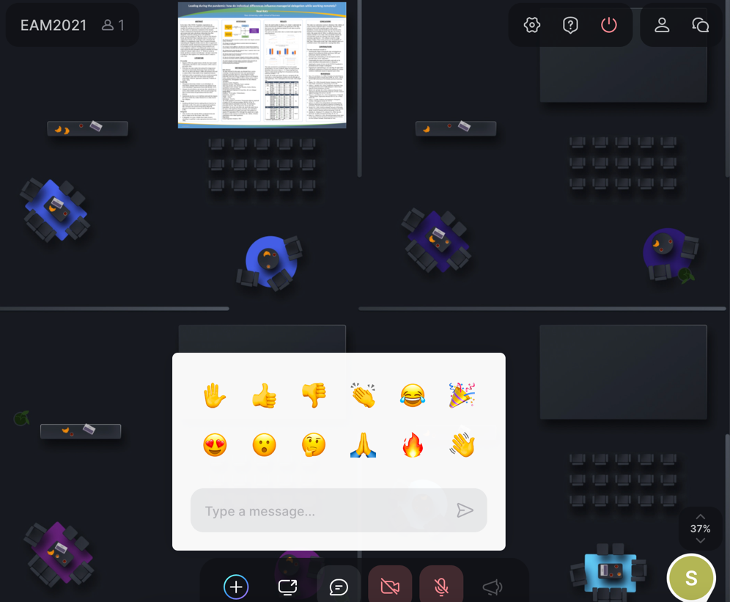
By highlighting the chat box, you will see soft key options that simulate reactions in which the audience and presenter can see. These options include clapping, thumbs up, or raising your hand to ask a question or say something. When you are ready to leave the room, simply click into another room, or if you are ready to leave the conference, click the red “power” symbol in the upper right-hand corner to exit the Spatial Chat conference.

